My Mythical Creature
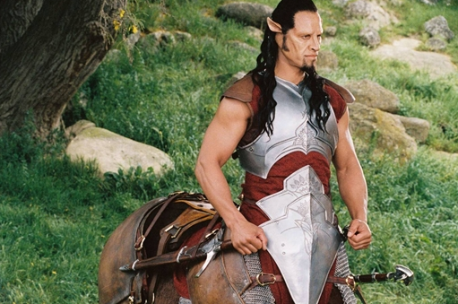
This is a centaur. They lived in mountains, forests, on beaches, the island of Crete and everywhere. There weapons where swords, spears, axes, dagger, bows and arrows. They were half human, half horse. They had the body and legs of a horse, and the body, arms and head of a human. They ate what humans eat. Their size was is normally the size of a human.
By Ben

