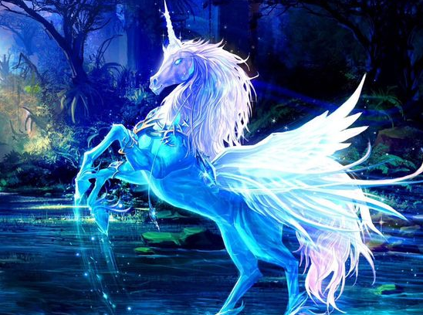
My Mythical Beast

The Unicorn
Unicorns are kind, beautiful and fearless creates from the Ancient Greek times. This creature will only attack you if you show a sign of harm. There are other kinds of unicorns that if you go near them there is a possibility that they will attack you.

