MATHS

ENGLISH:

Our English will focus on Non-Fiction Texts and the features within a Non- Fiction text book. Children will retrieve lots of information through reading texts and they will then write Non chronological reports about Nocturnal animals, which is our topic this half term! All spellings will be revised and children will receive 1 grammar lesson a day in preparation for SATS. Children will also complete comprehension practise papers. (Please don’t download these and use them at home as I have to use them for moderation evidence. Thank you)

Welcome back I hope you had a lovely Easter! There’s lots of work to do this half term which I’m sure the children will love! ☺ We will also be doing lots of revision for SATS. If you need to ask any questions please don’t hesitate. Lorraine Barlow

SCIENCE: **ANIMALS INCLUDING HUMANS**

In this topic children will look at how animals including humans have offspring which grow into adults. They will find out about the basic needs of animals, including humans, for survival. (Water food and air) They will also describe the importance for humans of exercise, eating the right amounts of different types of food and hygiene.

This half term we will focus on Position and Direction and problem solving using efficient methods.

Children will use mathematical vocabulary to describe position, direction and movement including movement in a straight line and distinguishing between rotation as a turn and in terms of right angles for quarter, half and three-quarter turns (clockwise and anti-clockwise).

Children will also revise strategies taught previously to support their SATS. Children will use exemplification materials to practise SAT style questions.



P. E.

This half term the children will develop and extend their sending and receiving skills; know rules for a game; develop simple group tactics; move actively and safely about the space and in teams.

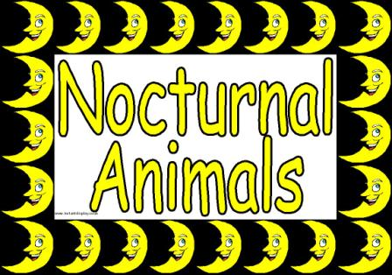

I.C.T.

### Children will continue to use word processing skills to produce a poster about a chosen nocturnal animal. They will use the WWW to research and discover facts. They will also learn how to copy and paste pictures into a word document. Look at [BBC Bitesize - KS1 Science - Nocturnal animals and birds](https://www.google.co.uk/url?sa=t&rct=j&q=&esrc=s&source=web&cd=7&cad=rja&uact=8&ved=0ahUKEwjW-cDssYnMAhUGVhoKHXQyALQQFggxMAY&url=http%3A%2F%2Fwww.bbc.co.uk%2Feducation%2Fclips%2Fzsshfg8&usg=AFQjCNGtrXJwYGRf4FuTaaEqefAJHFUcSg&bvm=bv.119408272,d.d2s)

ART/DT/ MUSIC

They will look at the artwork of Georgia O Keefe and create their own interpretation of her work with a focus on flowers.

In D/T Children will design a hedgehog house, bee house and bat box to place in our school garden.

R.E. **THE TORAH AND ITS IMPORTANCE TO JEWISH PEOPLE**

Children will be introduced to the Sefer Torah (the Torah scroll), Children will learn about how the Torah is regarded and treated and why it is so precious to Jewish people. They will have opportunities to consider what rules and teachings influence their own lives and what they value.