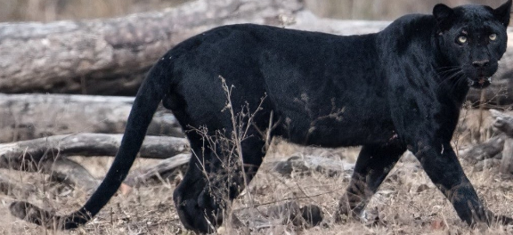
My mythical creature

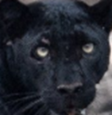

The winged two headed jaguar (his wings are black so there hidden) he lives in a ruin called portal ruin. The last time somebody went there he didn’t come back. He is bigger then a double decker bus and eats a whole vilige every year. He can turn invisable if he wants to that’s why no one has proof he is real.
By Micah

