The Blind Dog

My kindly human sighs for me,
But with my clever nose I see . . .

The perfumed path of a lady dog,
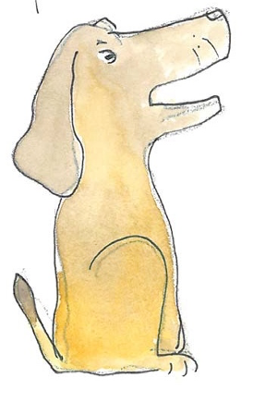
The fishy trail of a passing frog,
The sharp, clear stink of a scavenging fox,
The tempting scents of a cardboard box,

The glorious odours of dustbin day,
The tang of a lamp-post in my way,
The feathery whiff of a broken bird,
The traces of ice-cream, softly blurred,

The insults left by an old tom cat,
The slimy tracks of a sewer rat,
The homely smell of our garden gate,
The call of the gravy on my plate.

My kindly human sighs for me,
But with my clever nose – I see.

Clare Bevan

Interesting Places

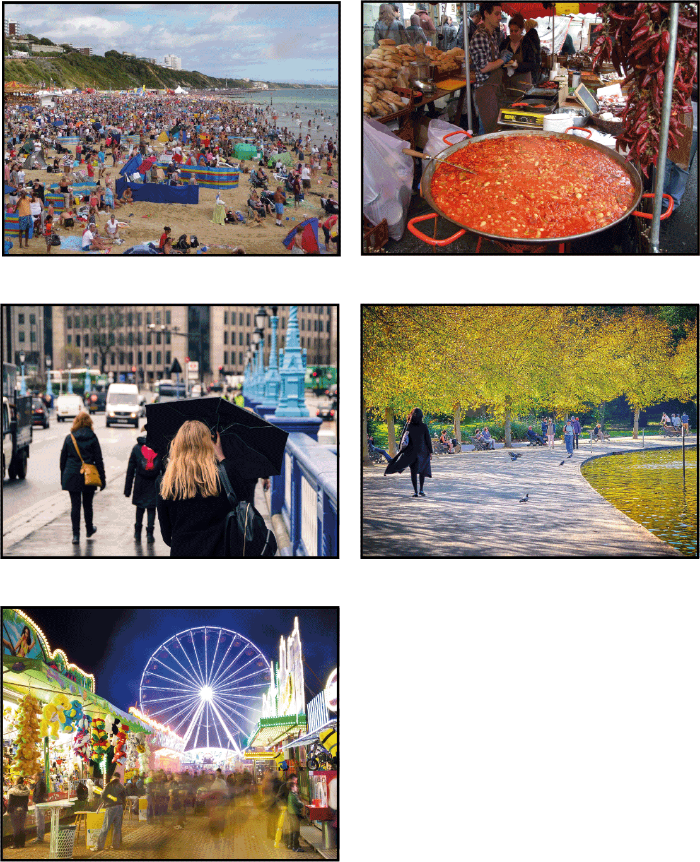

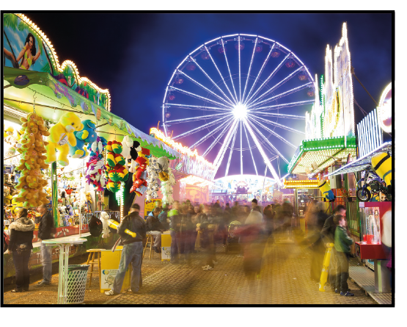
Building Poetry Lines

- Start with a noun from your list

screams

- Then think of some adjectives to describe them

Excited, loud, frenzied, high-pitched, raucous, noisy

- Combine the best with other words to build the image (adverbs, nouns)

The wholly excited, raucous, loud screams

- Then try to add other details (with prepositions, e.g. from, with or verbs: echo all around)

The wholly excited, raucous loud screams from the rollercoaster riders

- Finally try to add impact by adding or removing words

The wholly excited, raucous loud screams from the rollercoaster ride

When you are happy with your line, write it on a piece of lined paper.
You should end up with around eight lines of poetry.

Remember to use nouns from all the senses.
What can you see, hear, smell, feel and taste?

