ICT

We will use ICT to create art in the style of Piet Mondrian.

LITERACY

This half term we will be reading the Ted Hughes classic The Iron Man. We will be practising the correct punctuation for direct speech and developing our creative writing using adverbs.

We will take part in weekly English skills sessions to develop comprehension and appreciation skills and develop spelling, grammar and handwriting skills.

Please make time to hear your child read a few pages every other day.

This will greatly improve reading fluency whatever your child’s current level of confidence.

SCIENCE

Our topic this term is ‘Forces and Magnets’. We will develop our understanding of the forces around us by comparing how things move on different surfaces as well as observing the distinct features of magnetic force. We will work methodically, using scientific language to describe what we observe and using our knowledge to make and test predictions that further our understanding.

PE

We will be developing teamwork and tactics by playing football skills games. And we will be doing yoga to develop balance and coordination.

RE/PSHE

This term we will explore customs and traditions around the Christian Easter story.

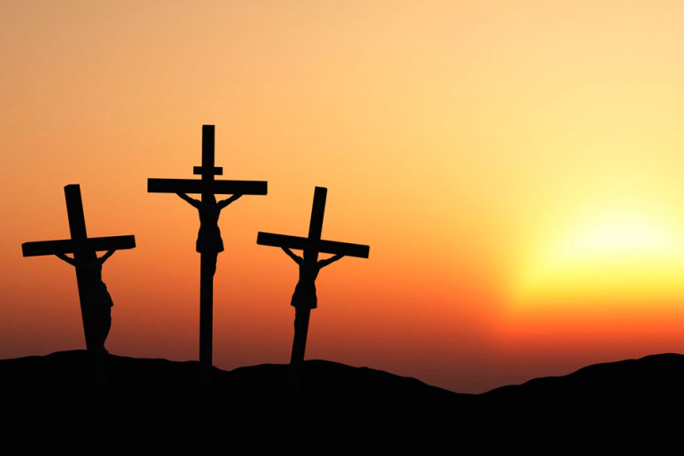

In PSHE we will contrast the blessings we have in our lives with people around the world and develop our attitude of gratitude.

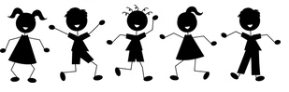

Spring Term 2 - YEAR THREE

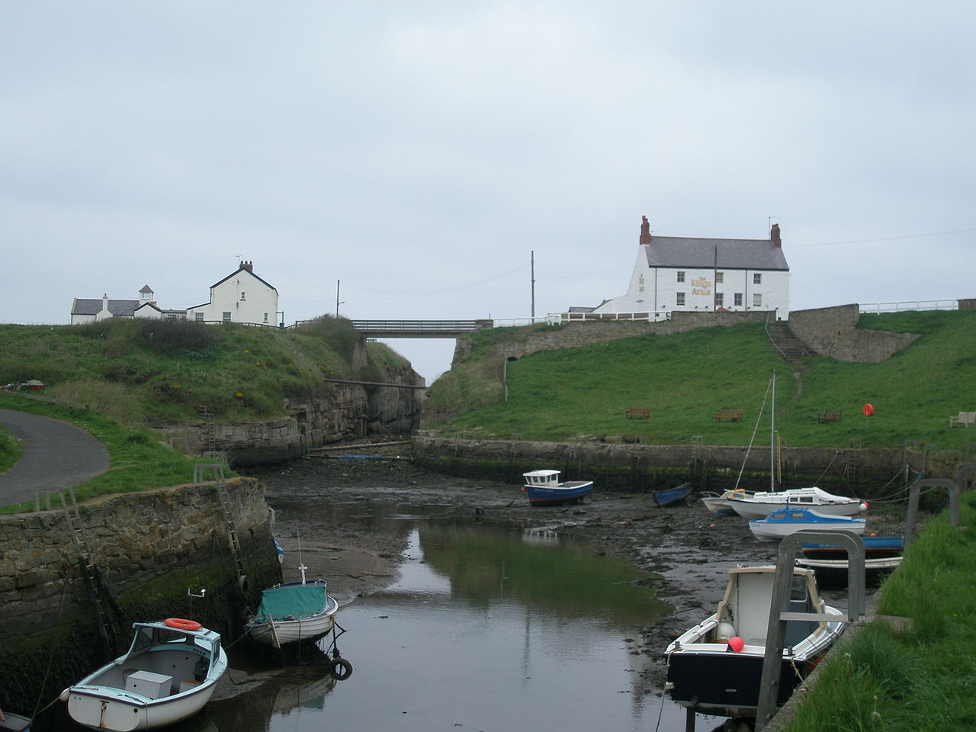

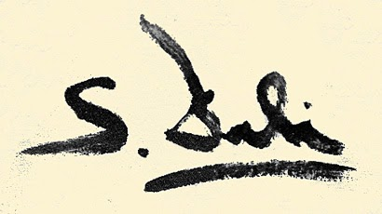



LANGUAGES

We will continue learning German this term. We will learn the names for pets and create our own memory game to practise them.



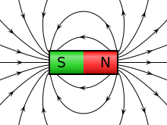

MATHEMATICS

This half term we will continue our work on measurement including measuring and converting lengths between mm and cm. We will be comparing lengths in metres and kilometres as well as calculating the perimeter of simple 2d shapes.

We will return to the subject of money, practising how to add up simple totals like you would in a café as well as working out what change you should receive in a shop.

Please continue to practise times tables with your child every week.

Mastery of tables facts is key to growing confidence in mathematics.

THE ARTS

This term Mr Peacock will teach us ukulele as a whole class. We are so excited to be the first class to use the new school ukes!

We will explore the work of Spanish artist Salvador Dali. He is a master of dream-like imagination and his work will stimulate our creativity this term.