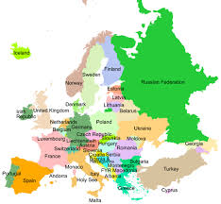
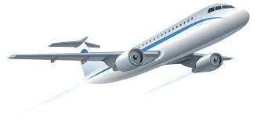
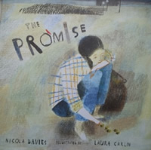

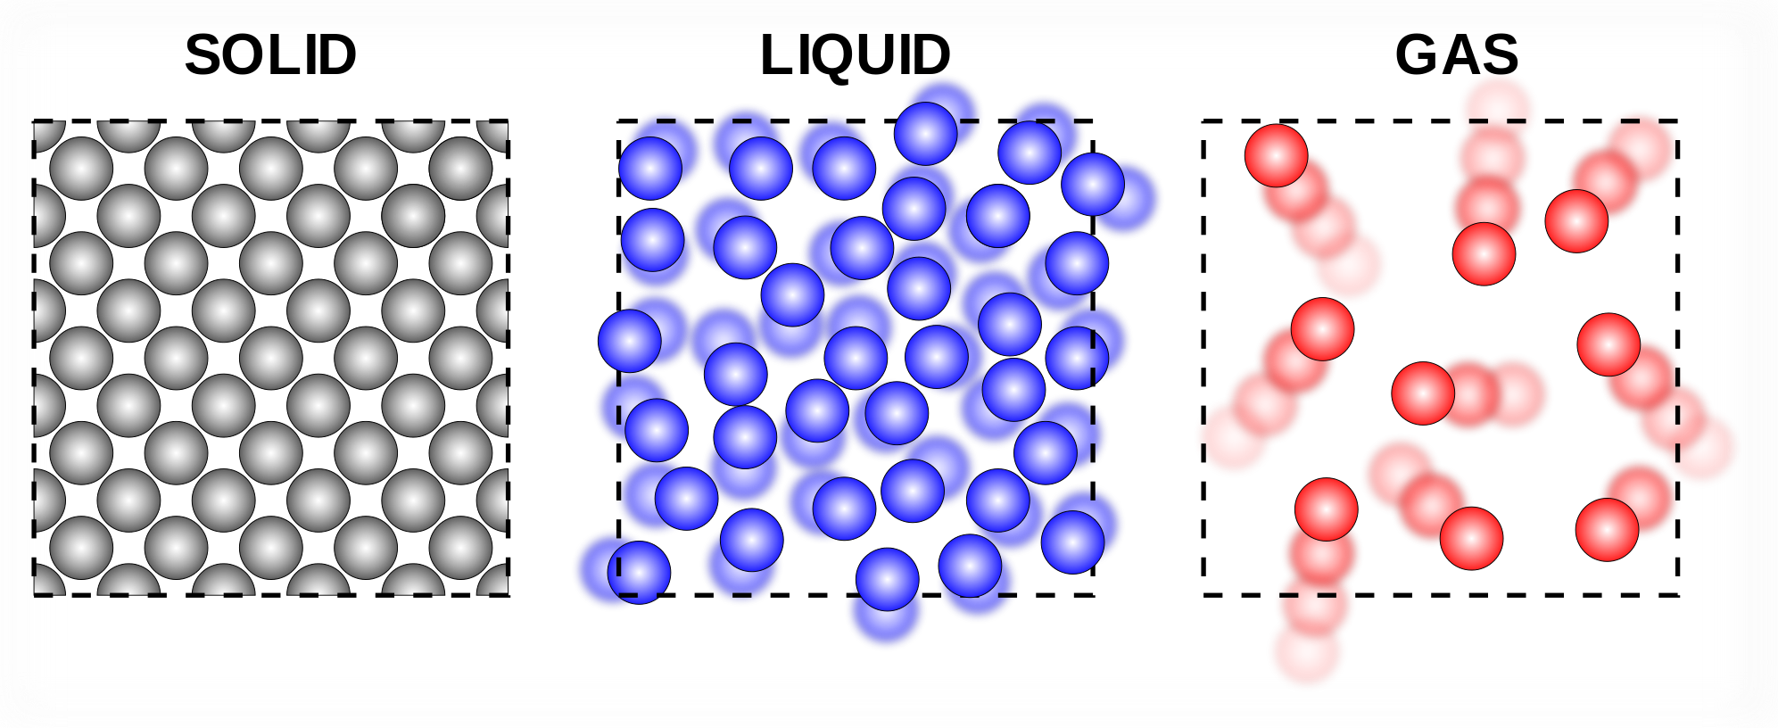
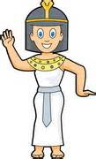
Spring Term 1-YEAR FOUR
Europe- Part One!
Teachers: Mrs Walsh, Mrs Bennett,
Mrs Calderwood, Mrs Dixon, Mrs Wake

LITERACY
To start this half term we will be reading the book ‘The Promise’ by Nicola Davies and basing our writing and grammar work on this. We will be thinking how to improve our writing using a range of descriptive writing techniques. We will also be focusing on looking for evidence in texts to support our understanding of it. Each week, our spellings will continue to be based on a spelling rule from the National Curriculum.

NUMERACY
We are all continuing to develop our independence through the ‘I Can Do Maths’ scheme and making great progress in applying many areas of maths to real life problem solving. We need to continue to work on our resilience when it comes to reasoning and problem solving in maths- so we will be doing a lot of investigations in maths this half term! We will also be learning about: decimals and how they relate to different fractions, negative numbers, dividing by 10, 100 and 1000 and co-ordinates. Our knowledge and speed of our times tables is improving, but we must make sure we know the inverse of these times tables and can recall them out of order.

P.E
We will continue to learn a range of dance moves from different cultures and try to put these moves together to form a routine from around the world. Following dance, we will be focusing on gymnastics in PE- learning how to safely use floor equipment and how to create routines on the floor in groups.
ICT
The children will be developing a greater understanding of how to sort data using IT programmes. We will also be learning how to use ICT to communicate with others.

SCIENCE
This half term we will be looking at ‘States of Matter.’ Within this we will be learning about the different molecule structures of solids, liquids and gases and reversible and irreversible changes. We will look at the effect cooling and heating has on different materials. The children will be asked to plan and carry out their own investigation during this topic.
THE ARTS
We will be looking at a range of famous European artists. Within this we will look at biographies of their lives, their famous art work and we will recreate our own versions of their art.
In music the children will learn about different styles of music from around Europe, such as traditional Irish music, punk music and flamenco music.

R.E and PSHE
In PSHE, we will continue to look at the ‘Big Life,’ with a particular focus on conservation and our environmental footprint. We will also be thinking about democracy and how our British Laws are based on a Christian ethos.

