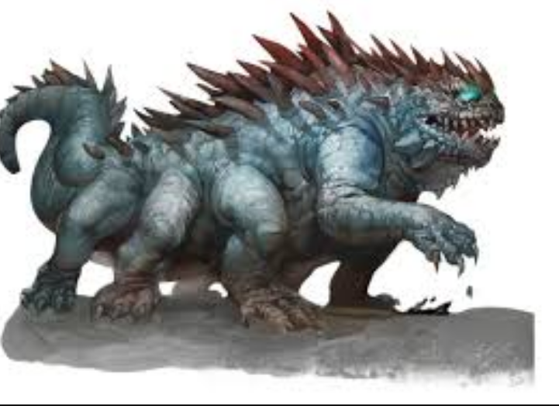
My mythical beast

This monster is the Spiker blob. It is kind and friendly but when it gets hungry it pushes spikes out of its back. Then you NEED to feed it! This is the only mythological beast that still can be found. But it is very rare. Its favourite food is tomatoes because it is vegan. Still, saying all this it is defiantly fearsome! It lives in a crater in Greece.
By Cassidy

