PE

We will be working with Mr Dowson to improve our athletics skills and of course we will also be working on our Makaton sign and dance routines ahead of our performance in the Northumberland Dance Festival!

LITERACY

In English we will learn how to write detailed character descriptions; create imaginative settings and narrative. We will use drama to help take on the roles of characters and understand how they feel. We will write diaries from the perspective of the characters we have explored.

We will also take part in guided reading to develop comprehension and appreciation skills; we will also develop our spelling. We will continue to develop our neat handwriting joins so look out for our fantastic curves.

SCIENCE

Our topic this term is ‘Light’. We will learn that light is needed in order to see things and notice that light is reflected from surfaces. We will also learn about the dangers of looking at the sun and explore our shadows.

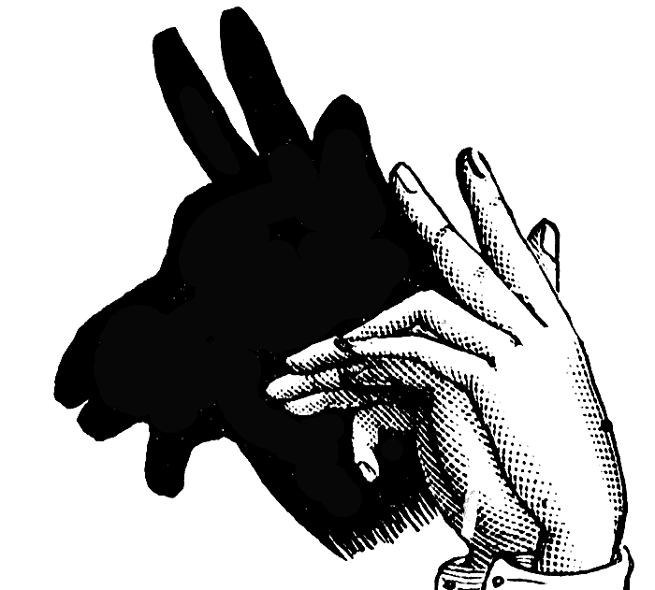

RE/PSHE

This term we will explore customs and traditions found in Judaism.



In PSHE we will explore what makes us angry and looking at calming techniques so that we can make positive choices.



Summer Term 1 - YEAR THREE

Roman Britain

MATHEMATICS

In maths we will be learning to recognise fractions as numbers, finding fractions of a discrete set of objects, adding and subtracting fractions with the same denominator, counting on in tenths and making a whole.

We will continue to work on our ICDM scheme which aims to boost problem solving skills across the KS2 maths curriculum.

Please continue to practise times tables with your child every week.

Mastery of tables facts is key to growing confidence in mathematics.

ICT

We will learn about how computers work and begin to write some basic code to programme a computer character.

HUMANITIES

This term we will be studying how the Roman Empire expanded so far and how native Celts felt about the newcomers…

DT / ART

In DT we will be exploring the magnificent Roman colosseum, learning about the structure of buildings and how to make them stable.

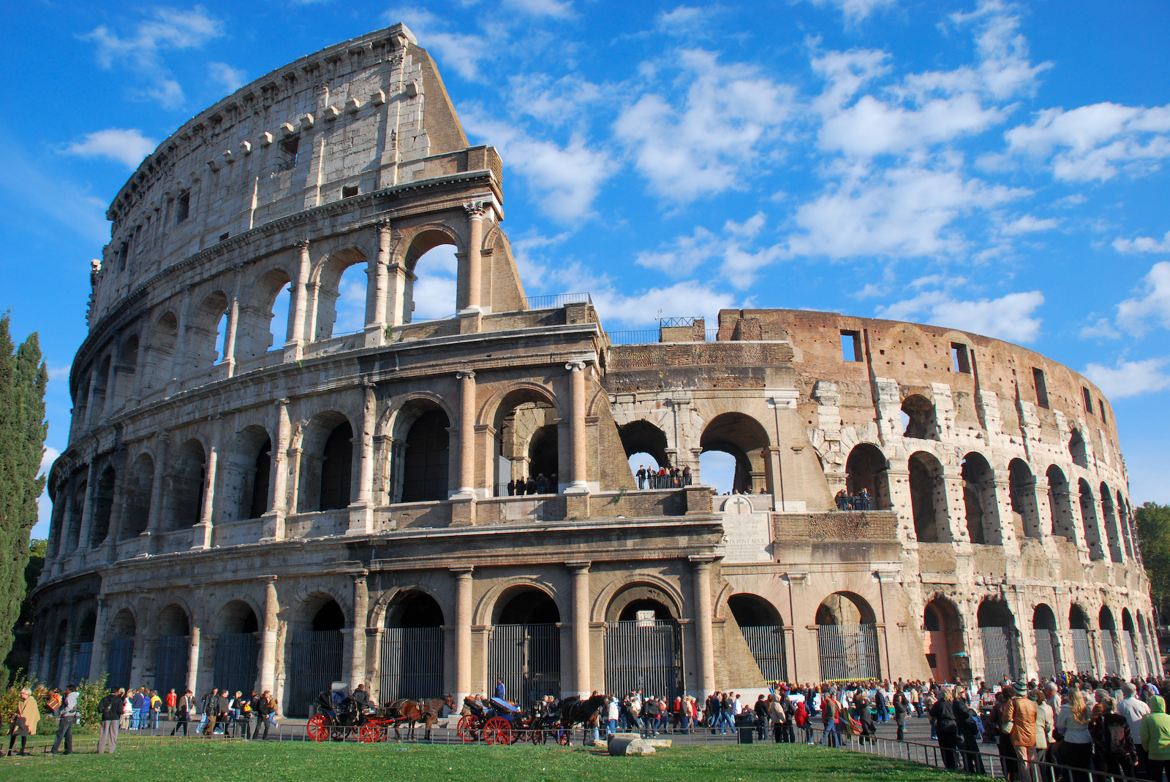

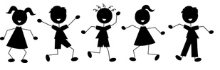

LANGUAGES

We will learn about saying how we feel and share what we have learned with our partner class.

