Revision Slides
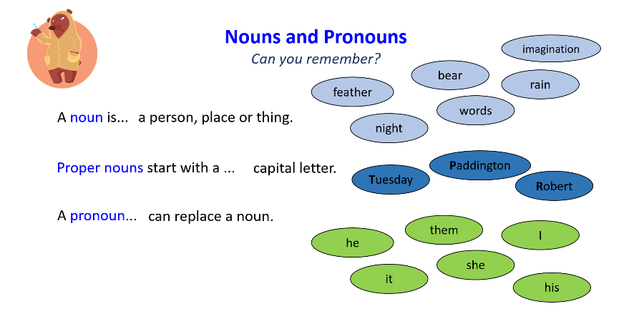
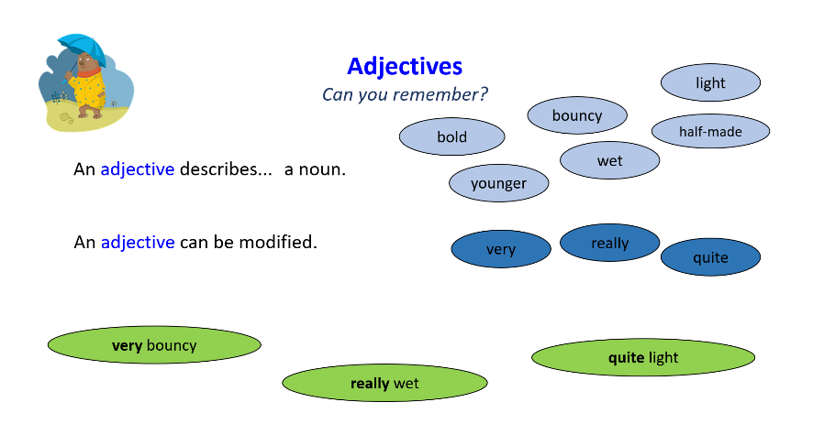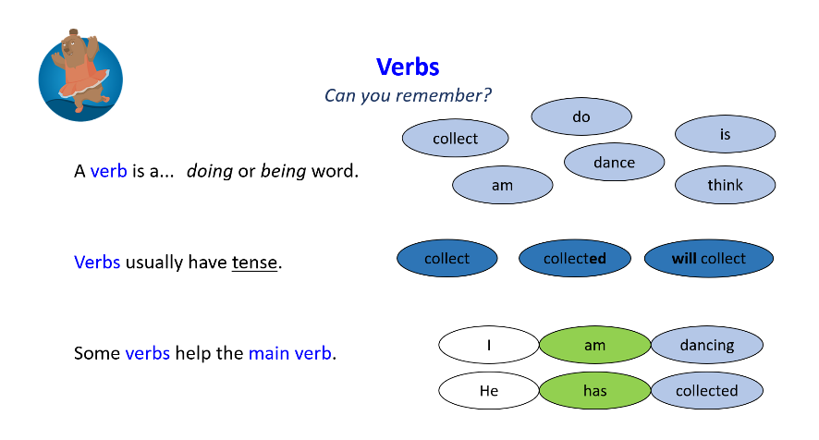
Verbs to Nouns
What do you notice about the word classes of these words?

What causes them to change?

argue → argument
decorate → decoration
invent → invention

Suffixes can change verbs into nouns

- Choose one root verb from each list and write two sentences that contain it, one as a verb and one as a noun (adding the suffix). Label the verb and noun.
- You will end up writing four pairs of sentences.

e.g. 1 A) When I run, I am happy. (verb)
1 B) The runner was happy. (noun)

-er
List 1
run – runner
play – player
win – winner
cry – crier (we change the y to i)
hike – hiker (we drop the extra e)

-ment
List 2
argue – argument (we drop the ‘e’ from argue and add –ment)
enjoy – enjoyment

-ation
List 3
inform – information
sense – sensation (we drop the ‘e’ from sense and add –ation)
prepare – preparation (we drop the ‘e’ from prepare and add –ation)
admire – admiration (we drop the ‘e’ from admire and add –ation)
decorate – decoration (we drop the ‘e’ from decorate and add –ation)

-ion
List 4
act – action
invent – invention
hesitate – hesitation (we drop the ‘e’ from hesitate and add –ion)
express – expression
confess – confession
expand – expansion (we drop the ‘d’ and add s and then –ion)
attend – attention (we drop the ‘d’ and add t and then –ion)

