Full of Surprises
Lesson 1
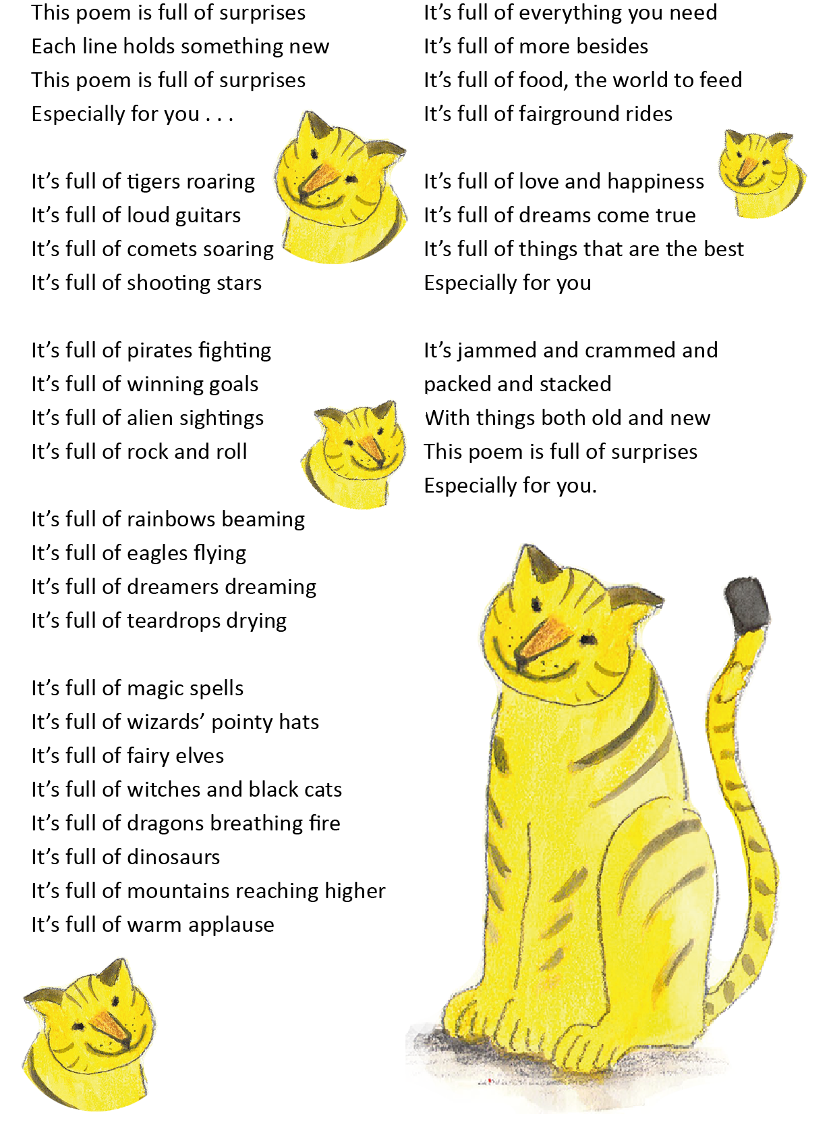
Paul Cookson p108, The Works 3

River

boat-carrier
bank-lapper
home-provider
tree-reflector
leaf-catcher
field-wanderer
stone-smoother
fast-mover
gentle-stroller
sun-sparkler
sea-seeker

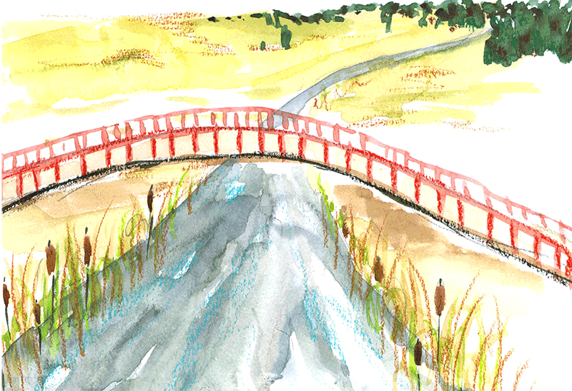

June Crebbin

p95, The Works 4

Thinking Prompt

Think about the two poems you have read and make notes on a piece of paper to answer the questions below.

What is the theme of each poem? (topic)

What do you notice about how each is structured? (layout)

How are they similar?

What is different about the poems?

Which would be best to perform? Why?

Which would you like to illustrate? Why?

What words, phrase or line stands out most in each poem? What gives these their impact?

Which poem do you like the best?

Explain why you prefer this poem.

