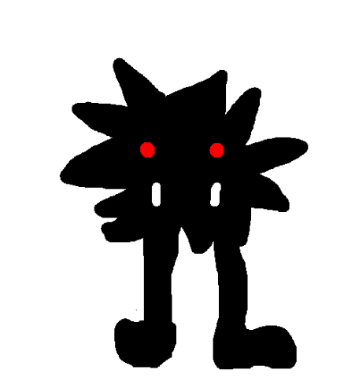
My Mythical Creature

This was the Blobledobis. You could have found it in a random beach cave of the cost of Crete the cave is called…The Blobbledobis Cave. The Blobbledobis it was 1ft tall but its legs were 3ft long and had fir as black as night and two fangs one millimetre long and its eyes were a pale red or a really dark pink.
To attack things it kicked it with its legs. It also tucked its legs in and rolled under peoples legs.
By Lana

