Seaton Sluice First School

Allergy Statement

**Seaton Sluice First School recognises that a number of community members (pupils, parents, visitors and staff) may suffer from potentially life-threatening allergies or intolerances to certain foods. As a school, we are committed to a whole school approach to the care and management of those members of the school community.**

**The school cannot guarantee a completely allergen free environment, rather to minimise the risk of exposure by hazard identification, instruction and information. This will encourage self-responsibility where appropriate to all those with known allergens to make informed decisions on food choices. Parents and carers are requested to provide details of allergies on admission to school.**

Aims:

* *To reduce the likelihood of a pupil or member of staff with a known food allergy displaying a reaction to a specific food while in school.*
* *To foster an understanding of and sense of responsibility for the specific needs of the individual members of the school community.*
* *To create an awareness of the action to take should someone with a food allergy display its symptoms.*
* *To ensure the school fully complies with the statutory guidance for supporting pupils with medical conditions.*

Common causes of allergies:

* Cereals containing gluten
* Celery including stalks, leaves, seeds and celeriac in salads
* Crustaceans (prawns, crab, lobster, scampi, shrimp paste)
* Eggs- also food glazed with egg
* Fish- some salad dressings, relishes, fish sauce, some soy and Worcester sauces
* Soya (tofu, bean curd, soya flour)
* Dairy and derivatives such as whey protein and food glazed with milk.
* Nuts (almonds, hazelnuts, walnuts, pecan nuts, brazil nuts, pistachio, cashew and macadamia nuts, nut oils, marzipan)
* Peanuts- sauces, cakes, deserts, ground nut oil, peanut flour
* Mustard- liquid mustard, mustard powder, mustard seeds
* Sesame seeds- bread, bread sticks, hummus, sesame oil
* Sulphur dioxide/sulphites (dried fruit, fruit juice drinks, wine, beer)
* Lupin, seeds and flour, in some bread and pastries
* Molluscs (mussels, whelks, oyster sauce, land snails and squid)

NB The above list is not endless and could also include other non-food triggers such as latex, soaps, wasp and bee stings etc.

The allergy to nuts is the most common high risk allergy. However, it is important to ensure that all allergies and intolerances are treated equally as the effect to the individual can be both life-threatening and uncomfortable, if suffered.

Medical Information

Parents/carers will highlight on a child’s school admission form any medical needs including any diagnosed allergies before starting school. If a child is diagnosed at a later date, the medication coordinator must be alerted as soon as possible.

For children with a food allergy, parents/carers will be invited into school to discuss and create with the medical coordinator (Mrs Bennett) a **bsaci Allergy Action Plan**. This will include details such as any allergy triggers and any required medication. If required, additional advice will be obtained from a doctor or allergy clinic.

The school meals are prepared by North Tyneside Council Food Services. Parents/carers of children with allergies will meet with a senior representative to formulate a personalised menu plan to cater for their allergy. Children in receipt of a personalised school meal plan will be identifiable eg showing a pass or wearing a lanyard that states their allergy or medical condition such as diabetes. Individual Health Care Plans are displayed on the wall within the school kitchen.

Where epipens (adrenalin) are required as part of the Individual Health Care Plan:

* Parents/carers are responsible for the provision and timely replacement of the epipens. Two epipens are required.
* The epipens will be labelled and stored in a secure cupboard in the classroom of the child, easily accessible for staff but away from the pupils.
* Epipen training will be refreshed for all staff when we have a child requiring an epipen.

Parent/Carer’s Role

Parents/carers are responsible for providing medical information about their child’s allergy by completing the school data sheet or contacting the school and requesting an appointment to discuss with the medical coordinator. An appointment will then be arranged for a plan to be put in place.

It is the responsibility of the parents/carers to provide the school with up to date medication/equipment clearly labelled in the original container. The medication coordinator will also check the medical cupboard every half term to check expiry dates.

Parents/carers are required to provide up to date emergency contact information.

Snacks and lunches brought into school are provided by each child’s parent/carer. It is their responsibility to ensure that the contents are safe for the child to consume and clearly labelled with the child’s name on.

Parents/carers should liaise with staff about appropriateness of snacks and any food-related activities such as cooking and science experiments.

Parents/carers may be asked to provide a list of food products and derivatives their child must not come into contact with.

The parents/carers have a responsibility to talk with their child about their allergy and the importance of not sharing food/sticking to their own plan.

Staff Role

Staff are responsible for familiarising themselves with the policy and to adhere to health and safety regulations regarding food and drink.

* All staff must have a current copy of the medical needs register as well as any Individual Health Care Plans of children in their class. These records are confidential and will be stored securely.
* Upon determining that a child attending school has an allergy, a team meeting will be set up as soon as possible where all staff concerned attend to update knowledge and awareness of the child’s needs.
* All staff who come into contact with the child, including external staff who work with the pupils on the school site, will be made aware of the allergy, triggers, treatment and where medication is stored.
* All staff will promote handwashing before and after eating.
* Snack time food will be monitored by staff and are nut free and other allergens depending on the children attending. All staff will know the procedures at snack and lunch time to ensure the safety of children with allergies. However, staff cannot guarantee that foods will not contain traces of nuts.
* All tables will be cleaned daily with an approved solution or as required for activities involving food preparation.
* All staff will ensure that children do not share food brought in from home or provided during meal times.
* Emergency medication will be easily accessible at all times.
* Staff will liaise regularly with parents/carers about snacks and any food-related activities; parental consent must be sought.
* The school will always have an in-date epipen stored in the medical cupboard in the event of a person showing signs of anaphylaxis.

PTA and Charity Events

If the school hosts charity events or PTA events, it is important that no food poses a risk to any person (child or other). Where products are not made by school staff, but sold by the school or PTA, appropriate signage must be in place. This will state:

***These products were not produced at Seaton Sluice First School, therefore we cannot guarantee that it does not contain nuts or any other allergen.***

The PTA should nominate their own representative who will take responsibility for the medical needs including allergies of children who attend various events. This should also include a policy clearly outlining parental/carer responsibility and that of the PTA.

Any child attending a PTA or charity event who has an allergy will be asked to wear an awareness raising sticker that identifies them as having a specific allergy. This will be given to them by the class teacher. The medical coordinator (Mrs Bennett) will also provide a list of pupils with medical needs to the Chair/Vice Chair of the PTA to share verbally with the volunteers and ensure they are aware of individual needs.

Whole School Events During the School Day

* The school will provide allergen free alternatives.
* Children with allergens will be served first and provided with a suitable item.
* If suitable alternatives cannot be found, school may contact the child’s parent/carer to request foods are sent into school which are safe for the child to consume.
* Products will be plated separately.
* Products will be stored separately (wrapped where possible) to prevent cross contamination to the other items available to the other children.

Symptoms of Allergic Reaction

Staff must be aware that allergies can present with a whole range of symptoms. Any of the following may be present, although most people would not necessarily experience all of these:

* Generalised flushing of the skin anywhere on the body
* Nettle rash (hives) anywhere on the body
* Difficulty in swallowing or speaking
* Swelling of the tongue/throat or mouth
* Alternations in heart rate
* Severe asthma symptoms
* Abdominal pain, nausea and vomiting
* Sense of impending doom
* Sudden feeling of weakness (due to drop in blood prerssure)
* Collapse and unconsciousness

Procedure in the event of allergic reaction with a pupil:

If pupil shows any signs of allergic reaction immediately administer medication advised in their allergy plan giving stated doze and adhering to the instructions.

Contact parents/carers immediately to alert them of allergic reaction ensuring an adult is always with the child.

Wait with child until parent/carer arrives at school. Record on school ‘Medical Incidents Log’ the details of the reaction including action taken.

Procedure in the event of anaphylaxis reaction:

If outlined on medical plan and/or there is a concern of anaphylaxis, use an adrenaline auto-injector if the person has one. If not, use the school’s epipen stored in the medical cupboard.

Call 999 for an ambulance immediately (even if they start to feel better). State that you think the person has anaphylaxis.

Remove any trigger if possible eg bee sting in the skin.

Lie the person down flat (unless unconscious, pregnant or having breathing difficulties).

Give another injection after 5-15 minutes if the symptoms don’t improve and a second auto-injector is available.

Locate nearest first aider and phone emergency contact eg child’s parents/carers.

Give antihistamine if available and the child is conscious and able to swallow. Make sure suitable dose is given.

Remain calm, make the child feel comfortable and provide them with space. If parents/carers haven’t arrived by the time the ambulance arrives, a member of school staff will accompany the child to hospital.

Ensure accident forms are completed in detail including completing the school ‘Medical Incidents Log’ the details of the reaction including action taken.

Example of Allergy Action Plan

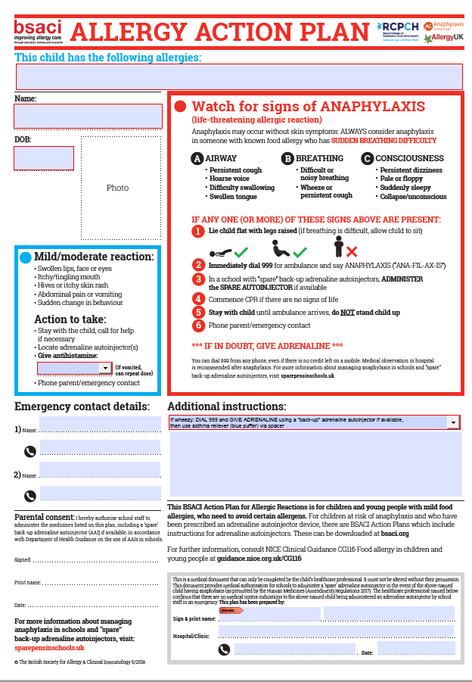

Date approved by governors:

September 2019

Date to be reviewed:

September 2020