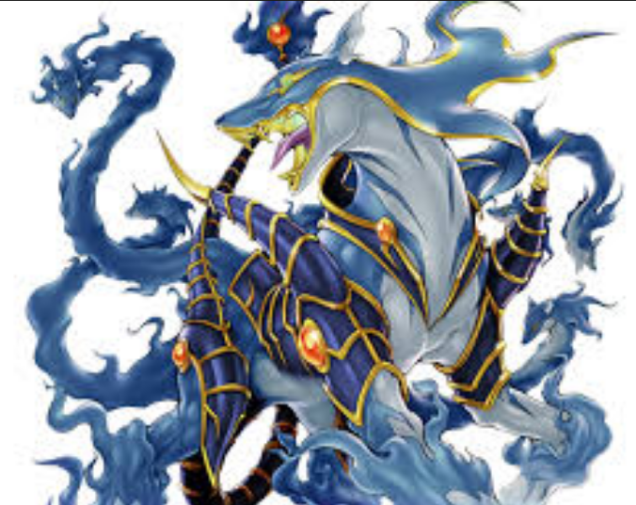
My Mythical Beasts

Foroxtion
A Foroxtion was a beast that roamed all the ancient ruins and temples. People used to pass around rumours that they had saw one but to be honest people who saw one would never live to tell the story. It’s appearance was most glorious but if a human being gazed into its eyes they would instantly disappear. It ate every day human souls cause nearly every day a person would try and slay this beast but the beast would kill them first. It was as big as a 3 strong men.

