SCIENCE

Our topic this term is ‘Light’. We will learn that light is needed in order to see things and notice that light is reflected from surfaces. We will also learn about the dangers of looking at the sun and explore our shadows.

Computing

We will try our hand at digital music making on line.

We will also continue to share work on our class blog – please visit us at:

LITERACY

We will be trying our hand at journalistic writing.

NUFC foundation will join us to work on interview technique and we will be looking at what makes good writing for newspaper reporting. We will also be writing and acting in our own plays based on the ancient myth of Romulus and Remus.

We will take part in weekly English skills sessions to develop comprehension skills as well as continuing to develop spelling, grammar and handwriting skills.

<http://ssfs.j2webby.com/>

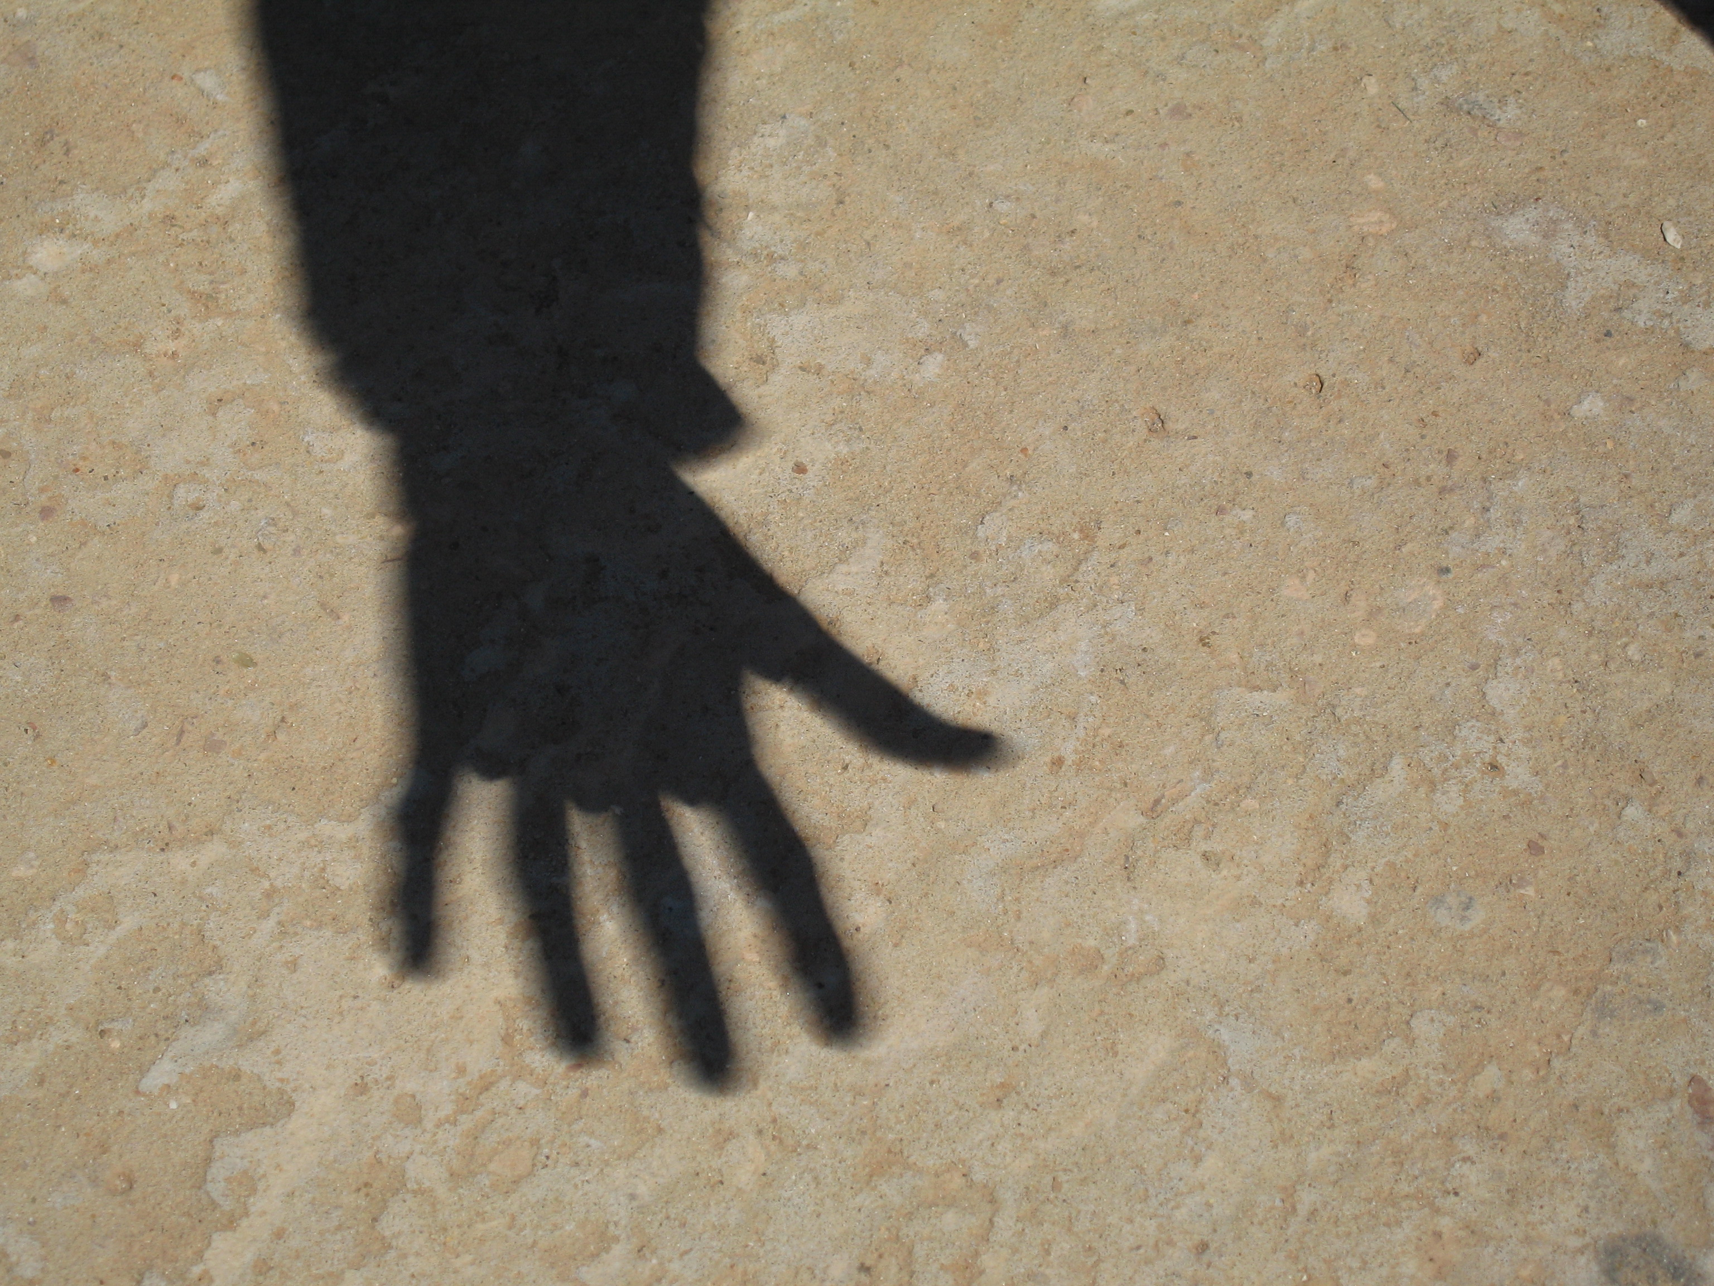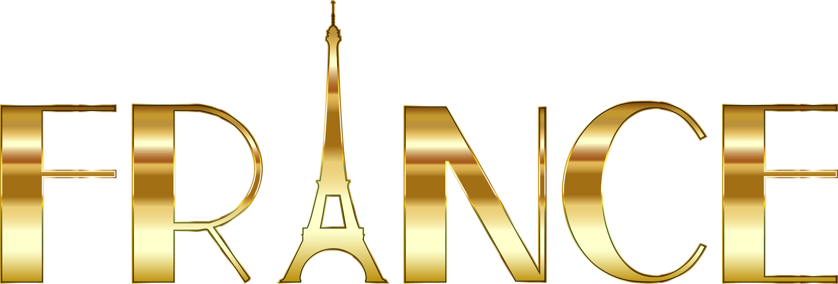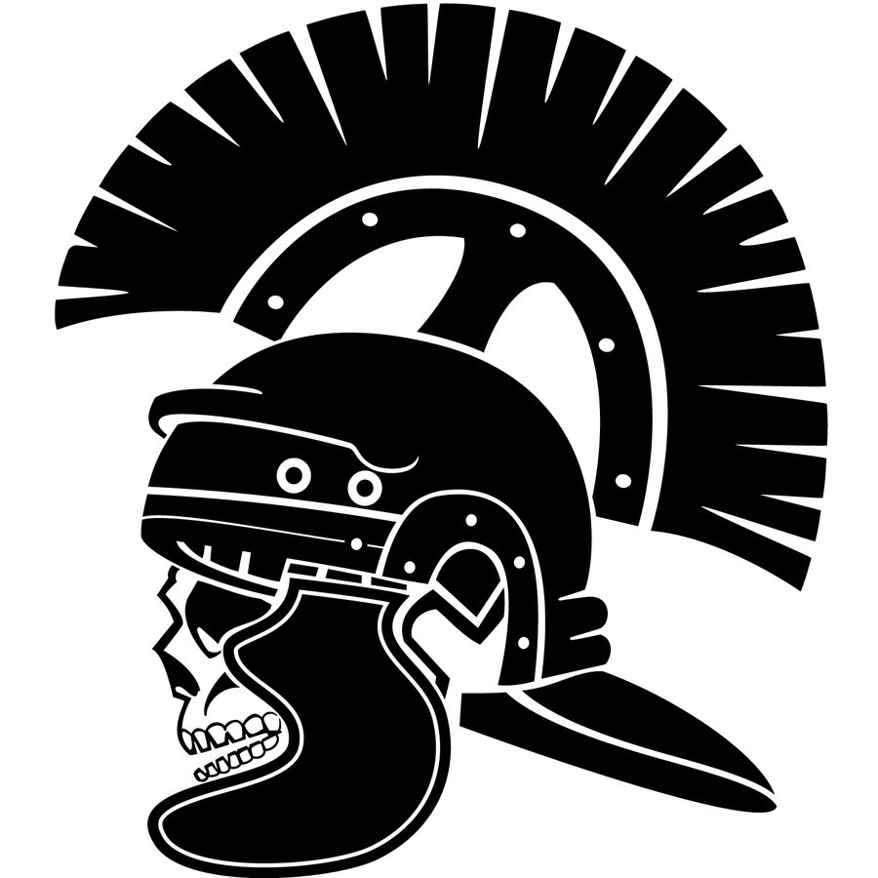

PE

This half term we will be focussing on athletics as we train for the highlight of our PE year… Sports Day!

Summer Term 2 - YEAR THREE

What did the Romans do for us?

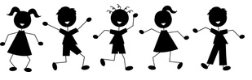

RE/PSHE

This half term we are going to be looking at Islam and the Five Pillars of faith that are key to this religion.

LANGUAGES

We will have an introduction to French – learning how to greet people and introduce ourselves.

NUMERACY

The children will learn how to tell and write the time from an analogue clock including using Roman numerals and 12 and 24 hour time. We will look at Roman numeral clocks and tell the time to the nearest minute. We will revise formal written methods of column addition and subtraction; add and subtract decimals using the context of money.

We will have a strong focus on developing the mathematical language that will help us to explain our methods and ideas.

Please do continue to practise times tables with your children every week. Mastery of tables facts is key to growing confidence in mathematics.

THE ARTS

We will also continue our ukulele lessons with Mr Peacock and our recorder work with our very own Mrs Bennett.

We will explore the work of Austrian artist Gustav Klimt.

