ICT

We continue to develop our programming skills using Scratch to create animations.

LITERACY

We will be developing our ability to write in an interesting way by drafting and editing our work as real authors do during the writing process. We will also be getting to grips with using a dictionary to improve our spellings and start using a thesaurus to make adventurous word choices.

We will take part in weekly English skills sessions to develop comprehension and appreciation skills and develop spelling, grammar and handwriting skills.

Please make time to hear your child read a few pages every other day.

This will greatly improve reading fluency whatever your child’s current level of confidence.

SCIENCE

Our topic this term is ‘Forces and Magnets’. We will develop our understanding of the forces around us by comparing how things move on different surfaces as well as observing the distinct features of magnetic force. We will work methodically, using scientific language to describe what we observe and using our knowledge to make and test predictions that further our understanding.

PE

We will be honing our gymnastic skills by putting together a routine of balances and basic acrobatics.



RE/PSHE

This term we will explore customs and traditions found in Sikhism and Buddhism

 

In PSHE we will focus on the power of setting goals for ourselves and how to stay motivated when we find something challenging.

Spring Term 1 - YEAR THREE

Chocolate



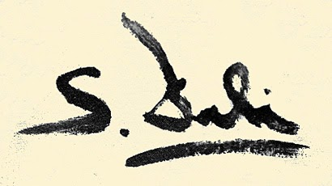



LANGUAGES

We will continue learning German this term. We will learn the names for pets and create our own memory game to practise them.



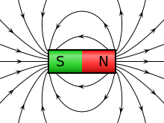

MATHEMATICS

This half term we will focus on measurement including measuring and converting lengths between mm and cm. We will be comparing lengths in metres and kilometres as well as calculating the perimeter of simple 2d shapes. We will take a closer look at telling the time – a key skill to master in the Year 3 curriculum. We need to be able to tell the time to the nearest minute, convert times between analogue and digital measurements and compare the durations of different events.

Please continue to practise times tables with your child every week.

Mastery of tables facts is key to growing confidence in mathematics.

THE ARTS

This term Mr Peacock will teach us ukulele as a whole class. We are so excited to be the first class to use the new school ukes!

We will explore the work of Spanish artist Salvador Dali. He is a master of dream-like imagination and his work will stimulate our creativity this term.