****

Mathematics

We will count out magic beans and buttons and match the amount to the numeral.

We will look at coins and play sorting and matching games.

We will try to put numbers in order up a beanstalk.

We will create patterns on gingerbread men.

Literacy

We will try to remember the sequence of events in our ‘story of the week”.

We will use ideas from these stories to stimulate our play.

We will play games which help us listen carefully to the rhythm and the sequence of sounds in words.

P.S.E.D

We will have a Special Person every day and celebrate achievements at school and from home when we read out the ‘proud letters’.

We will try to be a good friend but if we have a disagreement - we will try to sort it out by talking to each other.

We will think about our mums and Grandmas and say why they are special to us.

We will invite parents to play with us in Nursery at our Easter Stay and Play session.

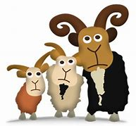

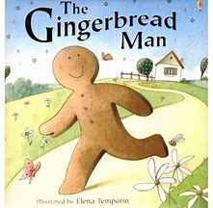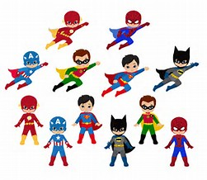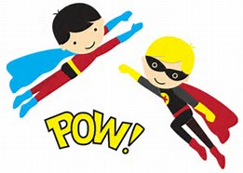

Physical Development

We will try to get changed into shorts and sandshoes for PE by ourselves!

We will explore different ways of moving, balancing and jumping on and off the climbing apparatus in our PE and soft play sessions.

We will continue to play and fiddle with small pieces of lego, jigsaws and play doh which will help us to develop muscles to hold a pencil correctly and make it move where we want it to without it wiggling.

Expressive Arts and Design

We will build bridges and paint beanstalks.

We will pretend to be different characters from our stories.

We will play percussion instruments and learn even more songs.

Understanding the World

We will bake bread buns and gingerbread men and lady biscuits.

We will plant a bean seed and watch it grow.

We will listen to the Easter story, eat hot cross buns and try to understand why we have them at Easter time.

Communication and Language

We will listen to traditional stories eg The Little Red Hen, Jack and the Beanstalk, The Gingerbread Man and enjoy joining in with the repeated refrains – Fee, Fi Fo Fum etc.

We will play games to help us recognise rhyming words.

We will choose a favourite song and see if we can sing it for our friends using our ‘talking stick’ to help us.